Latest News
Sunday 31 July 2017
From: Michael Fonfe
Received by: Email.
Crisis!

Saltwater Corrosion and Super Fierce UV Sunshine
Turn our Portable Pool into a Garden Tsunami

July is the seventh month of the year and, in our case, seven is not a lucky number. Our faithful above-ground fabric pool, held in shape by balancing the 50 ton-weight of water between the seams of its sides and the supporting counter-thrust of its tubular iron framework, collapsed this month. The relentless onslaught of saltwater spray off the beach had rusted through the frame in critical places and this, in turn, started a tear in the PVC s top sleeve, itself weakened by the equally relentless UV rays of the tropical sun. Once the structure had started to fail, the stress of grew a tear along the entire length of the long side of the pool, to deposit a mini-tsunami into the front garden. Luckily, no one was in the pool at the time. However, the pool is beyond economical repair and must be replaced.

We quickly identified a direct replacement in China. The Factory recommend using Grade 304 saltwater-resistant stainless steel for the frame and to run white or silver ‘Duck Tape’ along the PVC seams exposed to UV. Now we have to raise funds to buy a replacement, ship a 900Kg box it from Shanghai and then extract it from Colombo Port.

Until we have a new pool, we shall have to make do with just our Galle Pool, some 20 km away. It’s a severe set-back to our Project, of course. Naturally, we are doing all we can to raise funds to finance a new and more robust replacement pool .

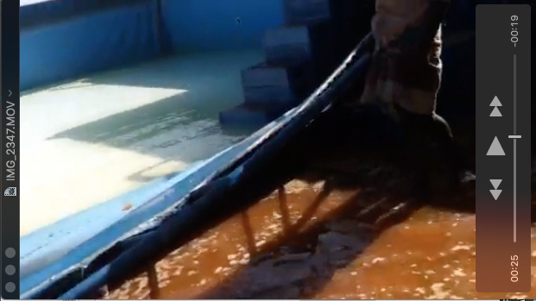
The Tear that Started it all – the Seam of the Top Sleeve

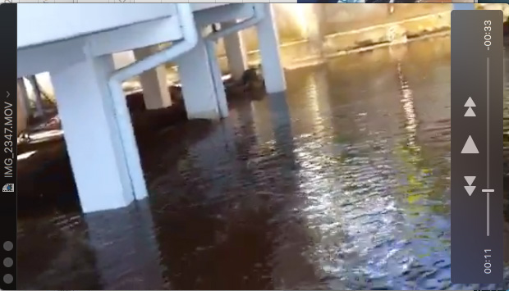
A garden tsunami. It is just as well my room is on stilts!

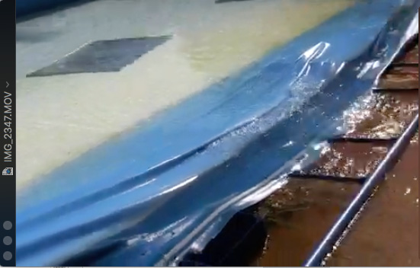
Laid flat as the last of the water flows out. Notice our pool mirror.

